截图：

一：

（1）

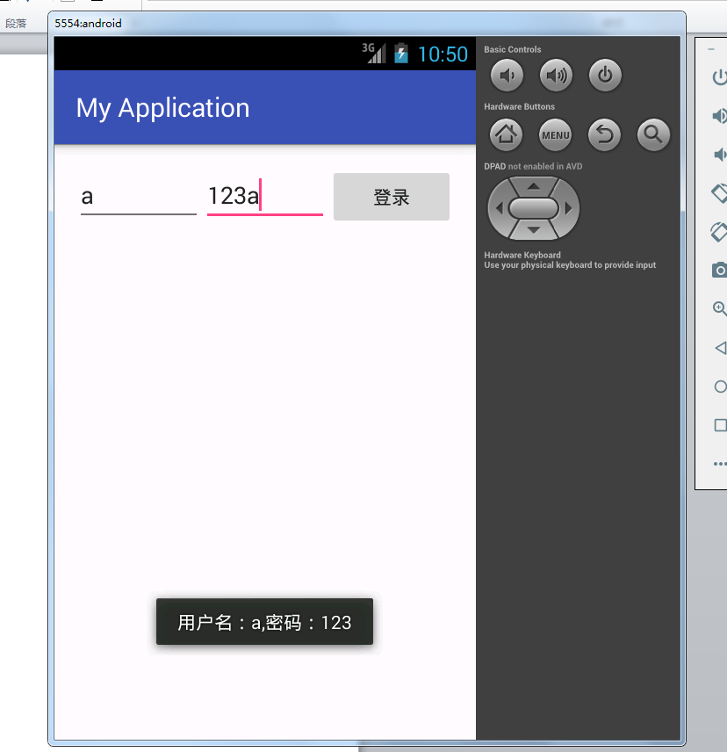

（2）

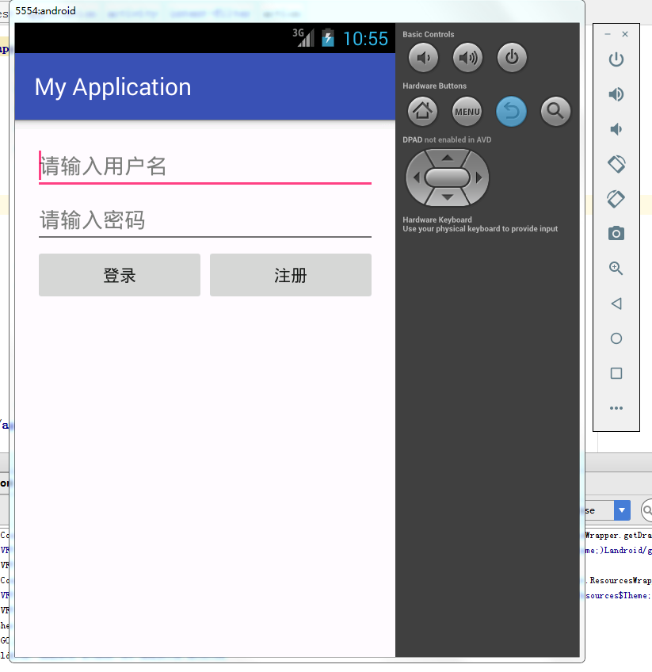

二：

（1）

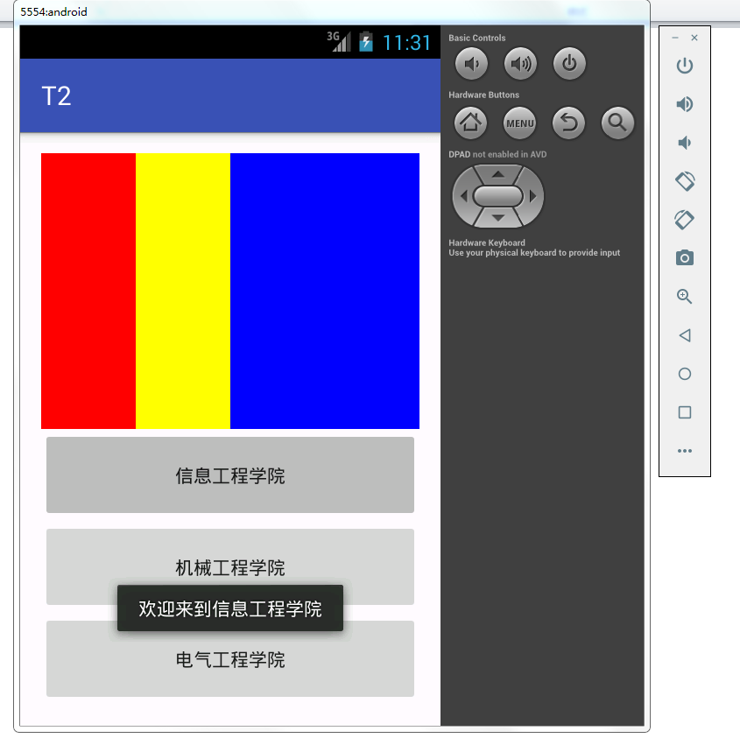

（2）

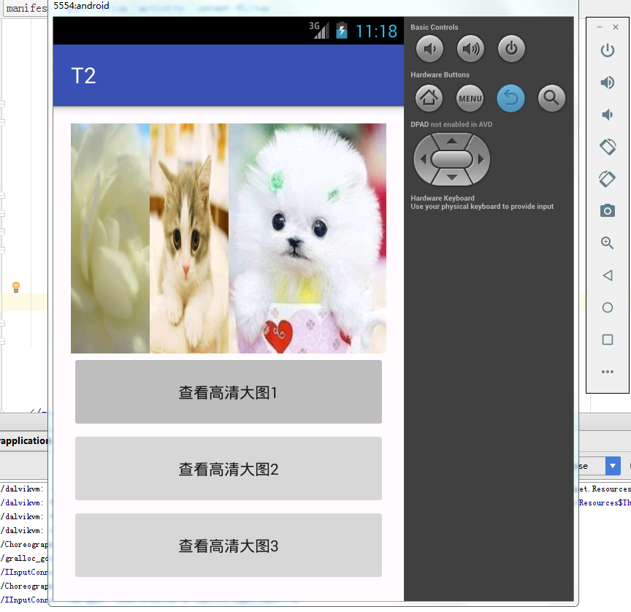

（3）

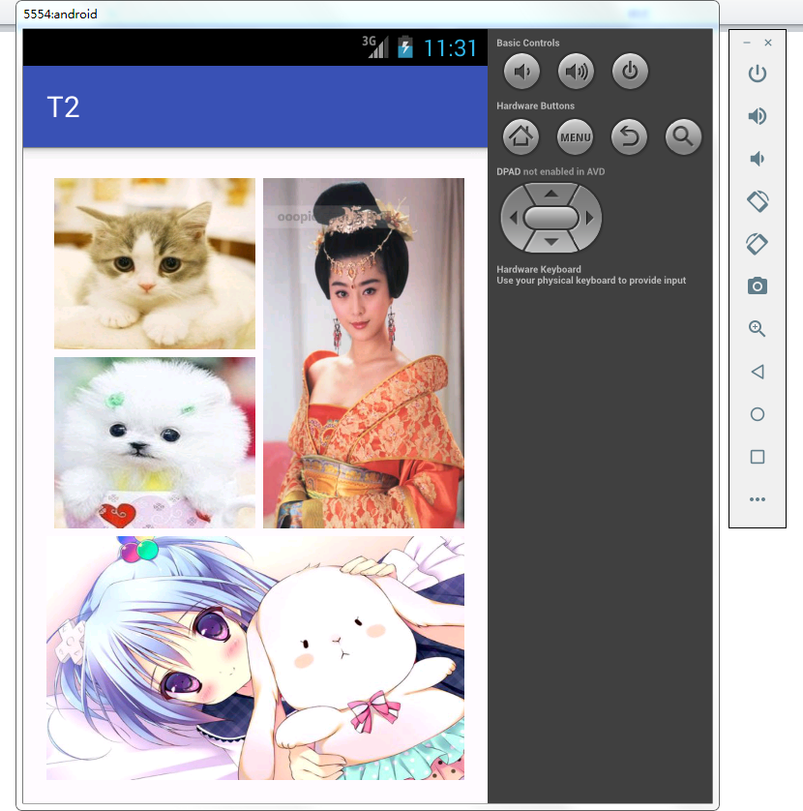

代码：

一：

（1）

*<?***xml version="1.0" encoding="utf-8"***?>*<**LinearLayout  
 xmlns:android="http://schemas.android.com/apk/res/android"  
 xmlns:tools="http://schemas.android.com/tools"  
 android:layout_width="match_parent"  
 android:layout_height="match_parent"  
 android:paddingLeft="@dimen/activity_horizontal_margin"  
 android:paddingRight="@dimen/activity_horizontal_margin"  
 android:paddingTop="@dimen/activity_vertical_margin"  
 android:paddingBottom="@dimen/activity_vertical_margin"  
 tools:context="com.example.administrator.myapplication.MainActivity"**>  
  
 <**EditText  
 android:id="@+id/ed1"  
 android:hint="用户名"  
 android:layout_width="0dp"  
 android:layout_height="wrap_content"  
 android:layout_weight="1"**/>  
 <**EditText  
 android:id="@+id/ed2"  
 android:hint="密码"  
 android:layout_width="0dp"  
 android:layout_height="wrap_content"  
 android:layout_weight="1"**/>  
 <**Button  
 android:id="@+id/bt1"  
 android:text="登录"  
 android:layout_width="0dp"  
 android:layout_height="wrap_content"  
 android:layout_weight="1"**/>  
</**LinearLayout**>

**package** com.example.administrator.myapplication;  
  
**import** android.support.v7.app.AppCompatActivity;  
**import** android.os.Bundle;  
**import** android.view.View;  
**import** android.widget.Button;  
**import** android.widget.EditText;  
**import** android.widget.Toast;  
  
**public class** MainActivity **extends** AppCompatActivity {  
  
 **private** Button **bt1**;  
 **private** EditText **ed1**,**ed2**;  
 @Override  
 **protected void** onCreate(Bundle savedInstanceState) {  
 **super**.onCreate(savedInstanceState);  
 setContentView(R.layout.***activity_main***);  
 findViews();  
 addLis();  
 }  
 **private void** findViews(){  
 **bt1** = (Button)findViewById(R.id.***bt1***);  
 **ed1** = (EditText)findViewById(R.id.***ed1***);  
 **ed2** = (EditText)findViewById(R.id.***ed2***);  
 }  
 **private void** addLis(){  
 **bt1**.setOnClickListener(**new** MyclickClass());  
 }  
 **class** MyclickClass **implements** View.OnClickListener{  
 @Override  
 **public void** onClick(View v) {  
 **if**(v == **bt1**){  
 Toast.*makeText*(MainActivity.**this**,**"用户名："**+(**ed1**.getText().toString())+**",密码："**+(**ed2**.getText().toString()), Toast.***LENGTH_SHORT***).show();  
 }  
 }  
 }  
}

（2）

*<?***xml version="1.0" encoding="utf-8"***?>*<**LinearLayout  
 xmlns:android="http://schemas.android.com/apk/res/android"  
 xmlns:tools="http://schemas.android.com/tools"  
 android:layout_width="match_parent"  
 android:layout_height="match_parent"  
 android:paddingLeft="@dimen/activity_horizontal_margin"  
 android:paddingRight="@dimen/activity_horizontal_margin"  
 android:paddingTop="@dimen/activity_vertical_margin"  
 android:paddingBottom="@dimen/activity_vertical_margin"  
 tools:context="com.example.administrator.myapplication.MainActivity"  
 android:orientation="vertical"**>  
  
 <**EditText  
 android:id="@+id/ed1"  
 android:hint="请输入用户名"  
 android:layout_width="match_parent"  
 android:layout_height="wrap_content"**/>  
 <**EditText  
 android:id="@+id/ed2"  
 android:hint="请输入密码"  
 android:layout_width="match_parent"  
 android:layout_height="wrap_content"**/>  
 <**LinearLayout  
 android:layout_width="match_parent"  
 android:layout_height="wrap_content"**>  
 <**Button  
 android:id="@+id/bt1"  
 android:text="登录"  
 android:layout_width="0dp"  
 android:layout_height="wrap_content"  
 android:layout_weight="1"**/>  
 <**Button  
 android:id="@+id/bt2"  
 android:text="注册"  
 android:layout_width="0dp"  
 android:layout_height="wrap_content"  
 android:layout_weight="1"**/>  
 </**LinearLayout**>  
  
</**LinearLayout**>

**package** com.example.administrator.myapplication;  
  
**import** android.support.v7.app.AppCompatActivity;  
**import** android.os.Bundle;  
**import** android.view.View;  
**import** android.widget.Button;  
**import** android.widget.EditText;  
**import** android.widget.Toast;  
  
*/**  
 * Created by Administrator on 2019/10/16 0016.  
 */***public class** MainActivity2 **extends** AppCompatActivity {  
 **private** Button bt1,bt2;  
 **private** EditText ed1,ed2;  
 @Override  
 **protected void** onCreate(Bundle savedInstanceState) {  
 **super**.onCreate(savedInstanceState);  
 setContentView(R.layout.activity_main_t2);  
 findViews();  
 addLis();  
 }  
 **private void** findViews(){  
 bt1 = (Button)findViewById(R.id.bt1);  
 bt2 = (Button)findViewById(R.id.bt2);  
 ed1 = (EditText)findViewById(R.id.ed1);  
 ed2 = (EditText)findViewById(R.id.ed2);  
 }  
 **private void** addLis(){  
 bt1.setOnClickListener(**new** MyclickClass());  
 }  
 **class** MyclickClass **implements** View.OnClickListener{  
 @Override  
 **public void** onClick(View v) {  
 **if**(v == bt1){  
 Toast.makeText(MainActivity2.**this**,**"用户名："**+(ed1.getText().toString())+**",密码："**+(ed2.getText().toString()), Toast.LENGTH_SHORT).show();  
 }  
 }  
 }  
}

二：

（1）

*<?***xml version="1.0" encoding="utf-8"***?>*<**LinearLayout xmlns:android="http://schemas.android.com/apk/res/android"  
 xmlns:tools="http://schemas.android.com/tools"  
 android:layout_width="match_parent"  
 android:layout_height="match_parent"  
 android:paddingBottom="@dimen/activity_vertical_margin"  
 android:paddingLeft="@dimen/activity_horizontal_margin"  
 android:paddingRight="@dimen/activity_horizontal_margin"  
 android:paddingTop="@dimen/activity_vertical_margin"  
 tools:context="com.example.t2.MainActivity"  
 android:orientation="vertical"**>  
  
 <**LinearLayout  
 android:layout_width="match_parent"  
 android:layout_height="0dp"  
 android:layout_weight="3"  
 android:orientation="horizontal"**>  
 <**TextView  
 android:layout_width="0dp"  
 android:layout_height="match_parent"  
 android:layout_weight="1"  
 android:background="#ff0000"**/>  
 <**TextView  
 android:layout_width="0dp"  
 android:layout_height="match_parent"  
 android:layout_weight="1"  
 android:background="#ffff00"** />  
 <**TextView  
 android:layout_width="0dp"  
 android:layout_height="match_parent"  
 android:layout_weight="2"  
 android:background="#0000ff"**/>  
 </**LinearLayout**>  
 <**Button  
 android:id="@+id/bt1"  
 android:layout_width="match_parent"  
 android:layout_height="0dp"  
 android:text="信息工程学院"  
 android:layout_weight="1"**/>  
 <**Button  
 android:id="@+id/bt2"  
 android:layout_width="match_parent"  
 android:layout_height="0dp"  
 android:text="机械工程学院"  
 android:layout_weight="1"**/>  
 <**Button  
 android:id="@+id/bt3"  
 android:layout_width="match_parent"  
 android:layout_height="0dp"  
 android:text="电气工程学院"  
 android:layout_weight="1"**/>  
  
</**LinearLayout**>

（2）同上差不多

（3）

*<?***xml version="1.0" encoding="utf-8"***?>*<**LinearLayout xmlns:android="http://schemas.android.com/apk/res/android"  
 xmlns:tools="http://schemas.android.com/tools"  
 android:layout_width="match_parent"  
 android:layout_height="match_parent"  
 android:paddingBottom="@dimen/activity_vertical_margin"  
 android:paddingLeft="@dimen/activity_horizontal_margin"  
 android:paddingRight="@dimen/activity_horizontal_margin"  
 android:paddingTop="@dimen/activity_vertical_margin"  
 tools:context="com.example.t2.Main3Activity"  
 android:orientation="vertical"**>  
  
 <**LinearLayout  
 android:layout_width="match_parent"  
 android:layout_height="0dp"  
 android:layout_weight="3"**>  
 <**LinearLayout  
 android:layout_width="0dp"  
 android:layout_height="match_parent"  
 android:layout_weight="1"  
 android:layout_marginRight="5dp"  
 android:layout_marginTop="5dp"  
 android:layout_marginBottom="5dp"  
 android:orientation="vertical"**>  
 <**TextView  
 android:layout_width="match_parent"  
 android:layout_height="0dp"  
 android:layout_weight="1"  
 android:background="@drawable/img1"  
 android:layout_marginBottom="5dp"**/>  
 <**TextView  
 android:layout_width="match_parent"  
 android:layout_height="0dp"  
 android:layout_weight="1"  
 android:background="@drawable/img2"** />  
 </**LinearLayout**>  
 <**TextView  
 android:layout_width="0dp"  
 android:layout_height="match_parent"  
 android:layout_weight="1"  
 android:background="@drawable/img3"  
 android:layout_marginBottom="5dp"  
 android:layout_marginTop="5dp"**/>  
 </**LinearLayout**>  
 <**TextView  
 android:layout_width="match_parent"  
 android:layout_height="0dp"  
 android:layout_weight="2"  
 android:background="@drawable/img4"** />  
</**LinearLayout**>